Lab Day-15 Sets

Questions

1. Write a Python program to Get Only unique items from two sets.

Input: set1 = {10, 20, 30, 40, 50}

set2 = {30, 40, 50, 60, 70}

Output

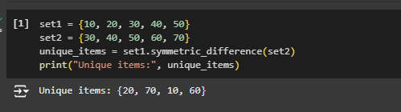

Questions

2. Write a Python program to Return a set of elements present in Set A or B, but not both.

Input: set1 = {10, 20, 30, 40, 50}

set2 = {30, 40, 50, 60, 70}

Output

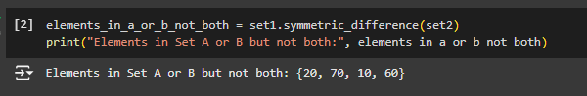

Questions

3. Write a Python program to Check if two sets have any elements in common. If yes, display the common elements.

Input: set1 = {10, 20, 30, 40, 50}

set2 = {60, 70, 80, 90, 10}

Output

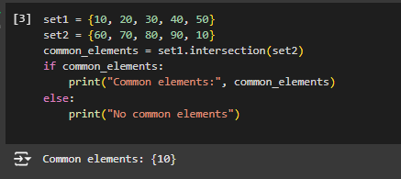

Questions

4. Write a Python program to Remove items from set1 that are not common to both set1 and set2.

Input: set1 = {10, 20, 30, 40, 50}

set2 = {30, 40, 50, 60, 70}

Output

